Web hacking 3, SQL injection, Xpath injection, Server side template injection, File inclusion
Structured Query Language (SQL)
Dynamic websites can use large amount of data. If a website stores e.g. the registered users then it is necessary to be able to save and access the data quickly. In order to have effective data management
data are stored in different databases where they are organized and structured. One of the most popular databases is the relational database. The relational databases have tables where each column
describes a characteristics and each row is a new data entry. The tables are connected to each other through the columns. Example:
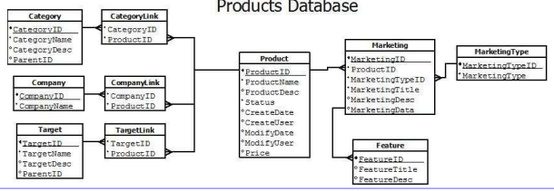
For accessing or modifying or inserting data the database query languages are used. SQL (Structured Query Language) is the most popular language to manipulate the database content. SQL has a special syntax and operates with the following main commands:
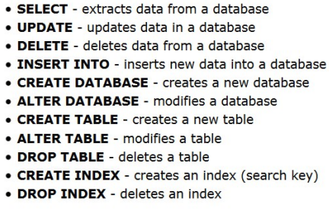

SQL command examples
- SELECT EmployeeID, FirstName, LastName, HireDate, City FROM
Employees
- SELECT * FROM Employees
- SELECT EmployeeID, FirstName, LastName, HireDate, City FROM
Employees WHERE City = 'London‘
- SELECT column1, column2, ...
FROM table_name
WHERE columnN LIKE pattern;
- SELECT column_name(s) FROM table1
UNION
- SELECT column_name(s) FROM table2;
- SELECT * FROM Employees limit 10 offset 80

SQL functional diagram
In order to use databases a db sever (e.g. mysql, postgresql, oracle) should be run that is accessible by the webserver.
It can be on the same computer (the db is running on localhost or on an other computer).
Since the website needs to access and modify the database, all server side script languages support database commands e.g. database connect, database query.
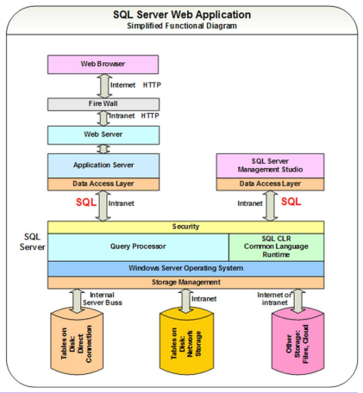

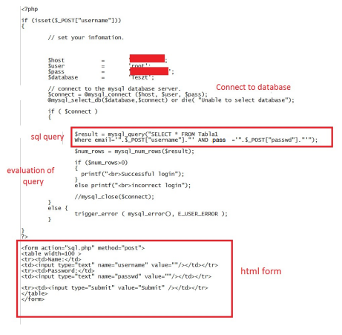
SQL with php example
Php uses the
mysql_connect,
mysql_select_db,
mysql_query,
mysql_num_rows
mysql_fetch_array
Etc. commands

SQL practice: Check your sql command
The following script prints out the generated sql query (it is only for demonstration, that never happens with real websites)
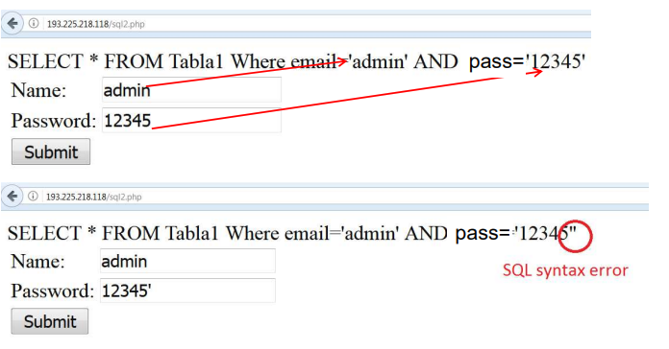
Simple sql injection exploitation
The easiest case of sql injection is when we have a direct influence on an action. Using the previous example we can modify the sql query to be true and allow the login. With the ‘ or ‘1’=‘1 (note that the closing quotation mark is deliberately missing, it will be placed by the server side script before the execution) the sql engine will evaluate the whole query as true because 1 is equal to 1 (1 now is a string not a number)
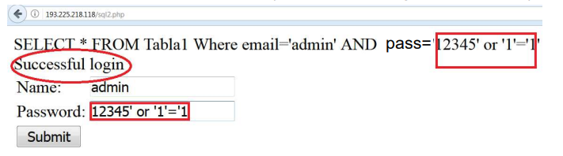
Normally attackers have to face much more complex exploitation.
Usually the attacker has only indirect influence on the website action.

Simple sql injection exploitation
If the server side query is more complex then the attacker will have to provide more sophisticated input:
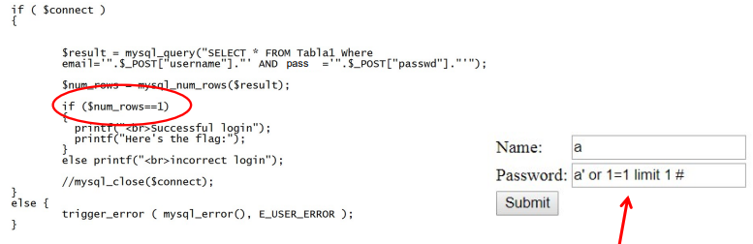
The previous solution does not work anymore, because the script only accepts the input when there’s only one row result (Note, the attacker can’t see the server side script, but he can guess).
How to modify the query to have only one row as result?

Type of sql injection exploitations
Based on the situation how the attacker can influence the server side sql query and the sql engine settings (what is enabled by the configuration and what is not) the attacker can choose from the following methods:

• Boolean based blind
The attacker provided an input and observes the website answer. The answer is either page 1 or page 2 (only two options). There’s no direct response to the attacker’s query but it’s possible to play a true and false game using the two different responses. The difference between the two responses can be only one byte or totally different (see example later).
• Error based
The attacker forces syntactically wrong queries and tries to map the database using the data provided by the error messages.
• Union query
The attacker takes advantage of the sql’s union select statement. If the attacker can intervene to the sql query then he can append it with a union select and form the second query almost freely (see example
later).
• Stacked query
If the sql engine supports stacked queries (first query; second query; etc.) then in case of a vulnerable parameter the attacker closes the original query with a semicolon and writes additional queries to obtain the data.
• Time based blind
It is the same as the boolean based, but instead of having two different web responses the difference is the response time (less trustworthy).

Besides that the attacker can obtain or modify the database in case of sql injection, the vulnerability can be used for further attacks as well if the db engine settings allow that:
• Reading local files
The attacker can obtain data expect for the database
• Writing local files
With the select into outfile command the attacker can write local files
• Executing OS commands
In some cases the db engine has the right to execute OS level commands

Blind boolean based sqli exploitation
Depending on the input the attacker can see two different answers from the server. Example:
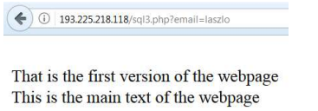

If we provide a non-existing user e.g. laszlo, the first version of the page appears. For valid users such as admin (The attacker doesn’t necessarily has valid user for the site) the second version appears.
Since there’s no input validation for the email parameter, the attacker can produce both answers:
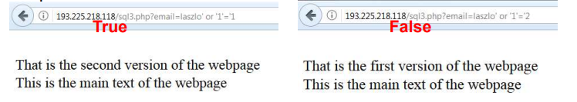
Blind boolean based sqli exploitation
Ok, we can enumerate the users in that particular case, but how can we obtain the whole database with only true or false answers?
There are special table independent queries that always work for specific database engines (general queries for mysql, postgresql, etc.). For example for mysql we can use the following queries:
- Mysql version: SELECT @@version
- Mysql user, password: SELECT host, user, password FROM mysql.user;
- Mysql databases: SELECT schema_name FROM information_schema.schemata;
- Mysql tables: SELECT table_schema,table_name FROM information_schema.tables WHERE table_schema != ‘mysql’ AND table_schema != ‘information_schema’

In order to execute such a query we need to arrange the current query to be accepted by the server side script (syntatically should be correct):
http://193.225.218.118/sql3.php?email=laszlo’ or here goes the query or ‘1’=‘2
Since the vulnerable parameter was escaped with a quotation mark, the query should end with a missing quotation mark (the server side script will place it, if there’s no missing quotation mark, the query will be syntatically wrong).
The second part of the query should be boolean too, e.g.:
http://193.225.218.118/sql3.php?email=laszlo’ or
ASCII(Substr((SELECT @@VERSION),1,1))<64 or ‘1’=‘2
The previous query checks if the ASCII code of the first character of the response of SELECT @@VERSION is less than 64.
Task: Find the first character of the db version!

Exploitation with sqlmap
Several tool exists for automatic sql injection exploitation. Sqlmap is an advanced sqli tool. The first step is to check if sqlmap manages to identify the vulnerable parameters)
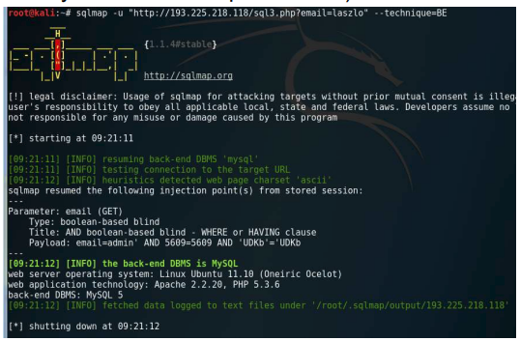

Exploitation with sqlmap
If sqlmap has identified the vulnerability the attacker could ask for specific data:
- --dbs: the databases in the db engine
- -D selecteddb --tables: the tables in the selected database
- -D selecteddb –T selectedtable --columns: the columns in the selected table of the selected database
- -D selecteddb –T selectedtable --dump: all data in the selected table of the selected database
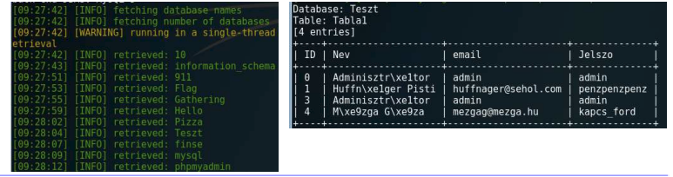
Writing local files with sql injection
Instead of asking for boolean result the attacker can use the select into outfile syntax to write a local file to the server. Since this is a new query the attacker has to chain it to the vulnerable first query (union select of stacked query exploitation). This is only possible if the following conditions are fulfilled:
- Union select or stacked queries are enabled
- With union select the attacker has to know or guess the row number and the types of the chained query (see example)
- A writable folder is needed in the webroot that later is accessible by the attacker
- The attacker has to know or guess the webroot folder in the server computer
Exploitation demo…
- First, guess the webroot and the writable folder
- Guess the number of columns from the original query and guess also the types of the rows
- Test the union select if it is executed with different row numbers
- Upload a simple string
- Find an attacking script and upload it
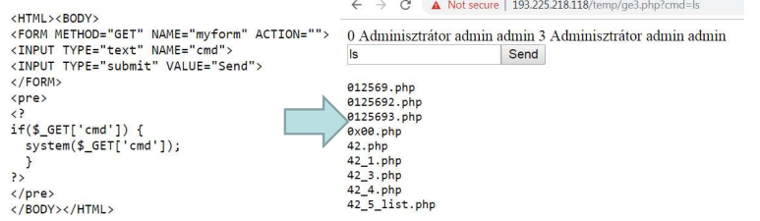
Sql injection filter evasion techniques
- White Space or 'a' = 'a'
- Null Bytes %00' UNION SELECT password FROM Users WHERE username='admin'--
- SQL Comments '//UNION//SELECT//password//FROM//Users//WHERE//na me//LIKE/**/'admin'--
- URLEncoding %27%20UNION%20SELECT%20password%20FROM%20Users%20WHERE %20name%3D%27admin%27--
- Character Encoding ' UNION SELECT password FROM Users WHERE name=char(114,111,111,116)--
- String Concatenation EXEC('SEL' + 'ECT 1')
- Hex Encoding Select user from users where name = unhex('726F6F74')

Xpath injection
Instead of storing datasets in databases, data can be stored in xml format.
Example
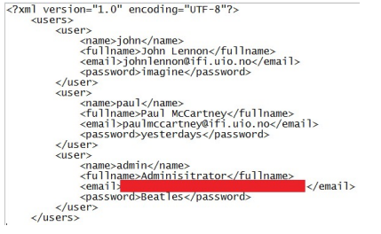

Xpath query with php
Xpath can be used to make a query, e.g. finding the full name of the user whose username is john and the password is imagine:
$xml->xpath("/users/user[name=‘john' and password=‘imagine']/fullname")
Finding the first user in the database:
$xml->xpath("/users/user[position()=1]/fullname")
Finding the penultimate user:
$xml->xpath("/users/user[last()-1]/fullname")
Other xpath functions can be used as well:
last(), count(node-set), string(), contains(), etc

Xpath injection is possible when there’s no input validation or the validation is inappropriate in the xpath query, e.g.
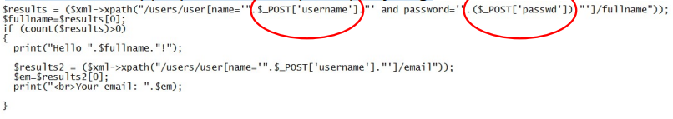
The exploitation of the vulnerability looks like an sql injection exploitation:
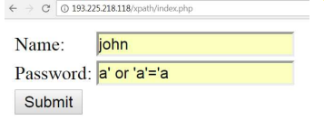

Server Side Template Injection (SSTI)
Template engines are widely used by web applications to present dynamic data via web pages. Unsafely embedding user input in templates enables Server-Side Template Injection. Example:
$output = $twig->render("Dear {first_name},", array("first_name" => $user.first_name) );
If a user input is substituted as template parameter without proper validation then the vulnerability appears:
$output = $twig->render($_GET['custom_email'], array("first_name" => $user.first_name) );
After detecting the vulnerability the next step is to identify the template engine that was used (e.g. Smarty, Twig, Jade). Each template engine has specific exploitation. In case of a successful exploitation the attacker can even execute arbitrary shell commands.

Local File Inclusion
Local file inclusion (LFI) is a vulnerability when the attacker can include a local file of the webserver using the webpage. If the server side script uses an include file type of method and the input for the method is not validated then the attacker can provide a filename that points to a local file:
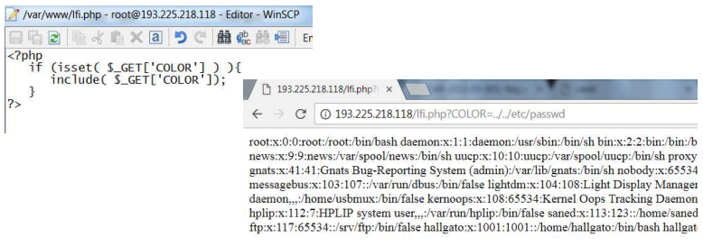
Exploitation of the LFI vulnerability
Adding null character at the end of the directory sometimes works when the normal exploitation fails:
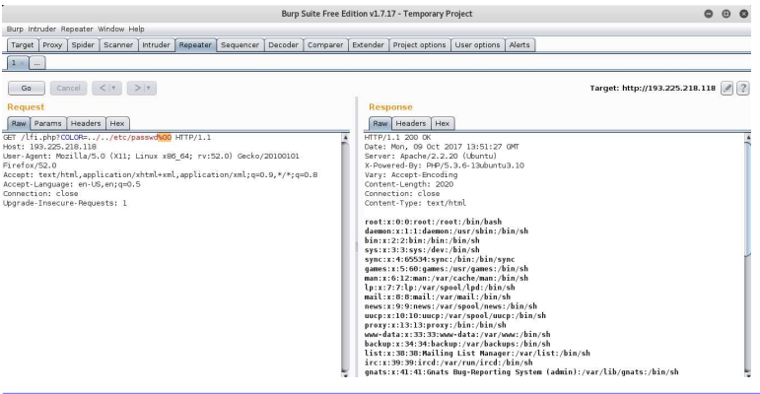
In addition to obtaining local files an additional aim is to upload attacking scripts and execute commands.
Depending on the server and the php settings executing php scripts can be possible if the local file is the: php://input and the php script is the posted data:
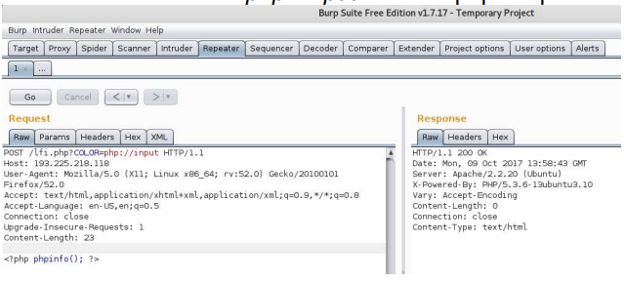
A php script source cannot be obtained through a browser, because the script is executed on the server side. But using encoding and php://filter as input the server side scripts can be obtained too. Since Php 5.0.0 the php://filter/convert.base64-encode/resource function is enabled. It encodes the php file with base64 and the php script source reveals.
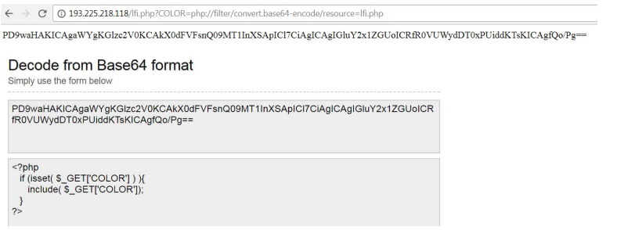
The most frequently used way for writing files to the server is to write the script in a local file first, then read it back through the LFI vulnerability.
How can the attacker place his own attacking script in a local file? One option is to access the /proc/self linux folder /proc/self/environ contains the current process info including the HTTP_USER_AGENT. If the attacker places the attacking script inside the user agent of the http head and the webserver has the right to access the /proc/self/environ file then he can execute any OS command in the name of the webserver application.
Note! Do not run the webserver as root! If the webserver is compromised and can be forced to execute commands then the command has the same rights as the server (the code is executed in the name of the server).
If the environ file is not accessible by the webserver then the attacker can try to find the webserver processid and access the environ file through the processid.
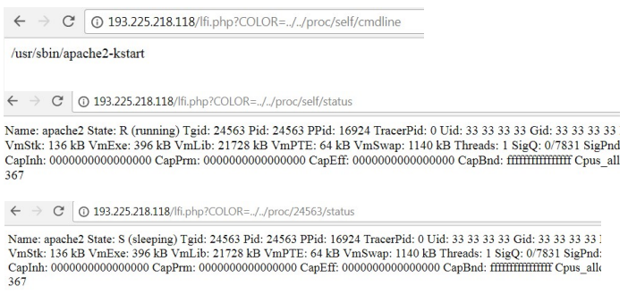
The attacker can also try to find the user agent by /proc/self/fd/ and brute-forcing the number (usually 12 or 14 in Apache)
/proc/self/fd/12
/proc/self/fd/14%00
/proc/self/fd/12
/proc/self/fd/14%00
/proc/<apache_id>/fd/12
/proc/<apache_id>/fd/14 (apache id is from /proc/self/status)
/proc/<apache_id>/fd/12%00
/proc/<apache_id>/fd/14%00

If the logs are accessible through the web server then the attacker can place the attacking php script in the logs to be executed in the same way as in the case of the /proc/self folder. The logs can be in various places, one option is to check /var/log/apache2 folder:

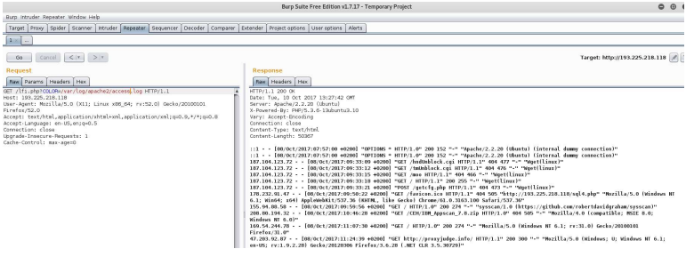
The attacker can influence the source ip, the web method, the http version, the url and the browser data in the logs. The easiest way is to modify the browser data (type of browser), because it’s a string, so php functions such as system() or phpinfo() can be substituted:
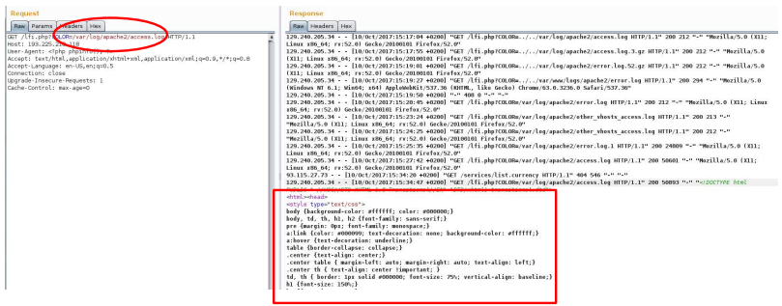
Instead of phpinfo, it’s better to use the system() php command:
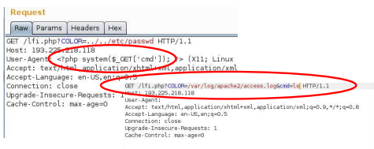

In this way the attacking script can be uploaded. If the log file is too long then the browser will not be able to display the logs.
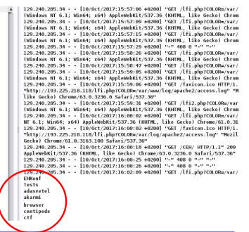

Remote File Inclusion
If the php settings allow, remote file can be inserted to the page.
Php settings relevant to remote inclusion:
allow_url_fopen: open file with fopen
allow_url_include: include, include_once, require and require
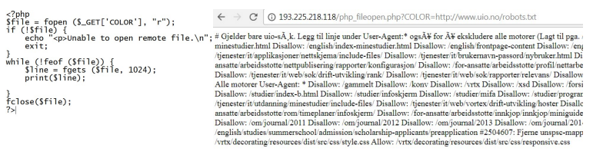
If the attacker can include remote files he will be able to include attacking scripts that are stored on an attacker controlled web server.

